Lab 2 Point Pattern Analysis-First Order Effect
Due September 16, 2014
- Packages for point pattern analysis in R

Libraries for point pattern analysis in R include: spatstat, splancs, and so on. We are going to use spatstat library for this lab exercise, which has over 280 user level functions. First of all, you need to install the library.

To load spatstat library, type

library(spatstat) #load the library
?spatstat #help for the library
data(japanesepines) #load Japanese pine data
jp<-japanesepines #assign it to a name jp
class(jp)

- Exploratory spatial point pattern analysis

To explore jp data briefly, get a summary and plot them

summary(jp)
plot(jp, axes =T, main=" Japanese black pine saplings") #plot

  - First order effect

Quadrat method using “quadratcount” command

quadratcount(jp, nx=2, ny=2) #2 rows and 2 columns
q.jp<-quadratcount(jp, 3,3) #3 rows and 3 columns
q.jp
plot(q.jp, axes =T, main ="Quadrat for JP data") #plot the quadrat
plot (jp, pch="+", main = "Quadrat for jp data")
plot (q.jp, add=TRUE, col="red", cex=1.5, lty=2)

Quadrat test for CSR

qt.jp<-quadrat.test(jp,3,3)
qt.jp

Based on the p-value, the point pattern of Japanese pine sapling is not CSR at =0.1 level. That is, the null hypothesis (CSR) is rejected.

plot(qt.jp, main="Quadrat Test: JP data")
plot(jp, pch="+", col="red", add=T)
Figure 1.
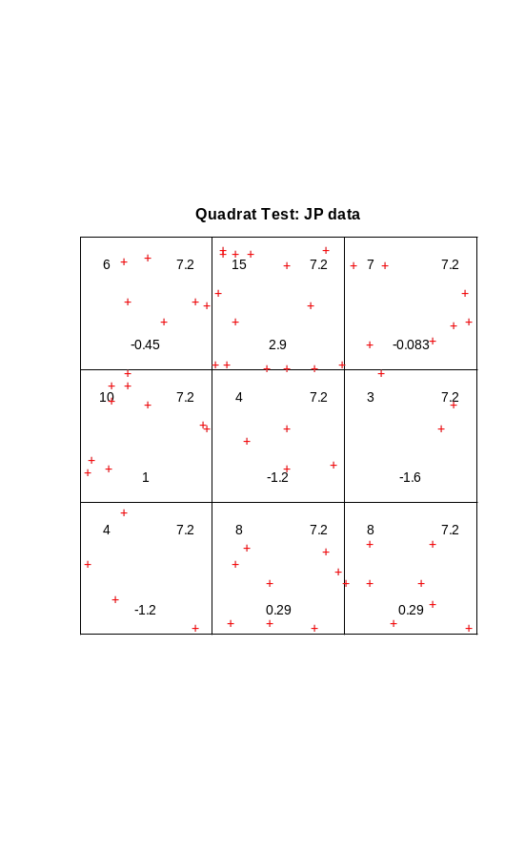
Assignment I
- Conduct Quadrat tests for Japanese pine sapling data with two different quadrats: (1) 2x2 and (2) 4x4. Report the results and state your statistical decision =0.1 level.
- For each test, include geographical output similar to Figure 1.
- Briefly discuss about the potential problem of quadrat analysis based on the results of the quadrat analysis with the 3 different quadrat definitions
- Provide your R code in the report

Kernel estimation

Results of kernel estimation can vary with different bandwidth inputs. In spatstat, density.ppp function returns the intensity using the isotropic Gaussian kernel of standard deviation sigma with point masses at each of the data points

?density.ppp
jp.Z.0.5<-density.ppp(jp, 0.05)
plot(jp.Z.0.5, main="Kernel Estimation of JP: sigma=0.05")
points(jp, pch="+", col="6")
jp.Z.1<-density.ppp(jp, 0.1)
plot(jp.Z.1, main=”Kernel Estimation of JP: sigma =0.1”)
points(jp, pch=”+”, col=”6”)

Assignment II
- Include the plots of kernel estimation with sigma =0.05 and sigma=0.1
- Describe first order effects in each plot of the two kernel estimations

  - Second order effect
Using nearest neighbor distances, second order effects can be explored. The Gest function returns 3 corrected Ghat (rs, km, hazard), and theoretical Ghat(theo). In this exercise, we will mostly use rs estimate of Ghat

jp.ghat<-Gest(jp)
g.max<-max(jp.ghat$r)
plot(jp.ghat, cbind(rs, theo)~r, main="G estimates", xlim=c(0, g.max), xlab="Dist")

Using point-to-event distances, second order effects can also be explored

jp.fhat<-Fest(jp)
f.max<-max(jp.fhat$r)
plot(jp.fhat, cbind(rs, theo)~r, main="F estimates", xlim=c(0, f.max), xlab="Dist")

K function is a tool to explore second order effects. Three K functions for estimating can be generated from Kest in spatstat: border, isotropic (or Ripley) and translate. It also returns theoretical Khat values. To get information about the other options, please refer the help file. In this exercise, we will use border corrected Khat.

jp.khat<-Kest(jp)
plot(jp.khat, cbind(border, theo)~r, main="K function for JP data")
#L plot
plot(jp.khat, sqrt(border/pi)-r~r, ylab="L(r)", main="L function for JP", ylim=c(-0.025, 0.025))
plot(jp.khat, sqrt(cbind(border, theo)/pi)-r~r,ylab="L(r)", main="L function for jp", ylim=c(-0.025, 0.025))

Assignment III
    - Create G estimates and F estimates plots without specifying xlim argument. Include the plots in your report
    - Interpret the plots (Ghat, Fhat, Khat, and Lhat) focusing on whether the point pattern is clustered, random, or regular and what leads you to the conclusion

